**The Revolutionizing Impact of Machine Learning on Healthcare and Finance**

[[Phindulo Makhado, MSc Coms Sci Cand, MSc Fin Eng](https://medium.com/@phindulo60?source=post_page-----95285658c6e7--------------------------------)](https://medium.com/@phindulo60?source=post_page-----95285658c6e7--------------------------------)

[Phindulo Makhado, MSc Coms Sci Cand, MSc Fin Eng](https://medium.com/@phindulo60?source=post_page-----95285658c6e7--------------------------------)

·

[Follow](https://medium.com/m/signin?actionUrl=https%3A%2F%2Fmedium.com%2F_%2Fsubscribe%2Fuser%2F23285d252ef0&operation=register&redirect=https%3A%2F%2Fmedium.com%2F%40phindulo60%2Fthe-revolutionizing-impact-of-machine-learning-on-healthcare-and-finance-95285658c6e7&user=Phindulo+Makhado%2C+MSc+Coms+Sci+Cand%2C+MSc+Fin+Eng&userId=23285d252ef0&source=post_page-23285d252ef0----95285658c6e7---------------------post_header-----------)

6 min read

·

Apr 10

2

Machine learning is a type of artificial intelligence that enables machines to learn and improve from experience. This is achieved by using mathematical algorithms to identify patterns in large amounts of data and using these patterns to make predictions or decisions. The use of machine learning has grown rapidly in recent years due to advancements in computing power and data availability. Machine learning significantly impacts various industries, including healthcare and finance, by enabling businesses to make more accurate predictions and decisions, and improving outcomes for individuals.

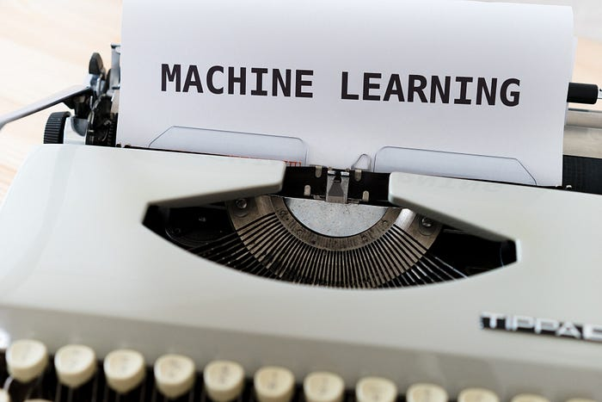

The basic idea behind machine learning is to use data to learn patterns that can then be applied to new data. This is achieved through the use of mathematical algorithms, such as linear regression, logistic regression, and decision trees. For example, linear regression is a mathematical model used to analyze the relationship between two variables, such as age and income. The model is represented by a line, which is used to make predictions about the value of the dependent variable (income) based on the independent variable (age).

Another common machine learning algorithm is logistic regression, which is used to classify data into categories, such as “fraudulent” or “non-fraudulent”. The algorithm uses a mathematical formula called the sigmoid function to map input data onto a probability scale between 0 and 1. Data points with a probability above a certain threshold are classified as belonging to one category, while those below the threshold are classified as belonging to the other category.

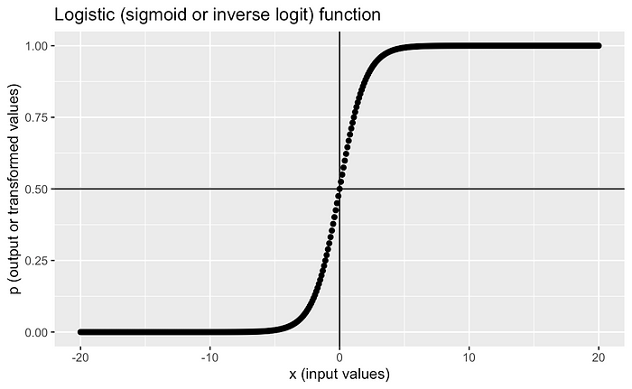

Decision trees are another type of machine learning algorithm used to make decisions based on a series of binary choices. A decision tree is represented as a flowchart-like structure, with each decision represented by a node and each possible outcome represented by a branch. For example, a decision tree could be used to classify customers as high or low risk based on their credit history, income, and other factors.

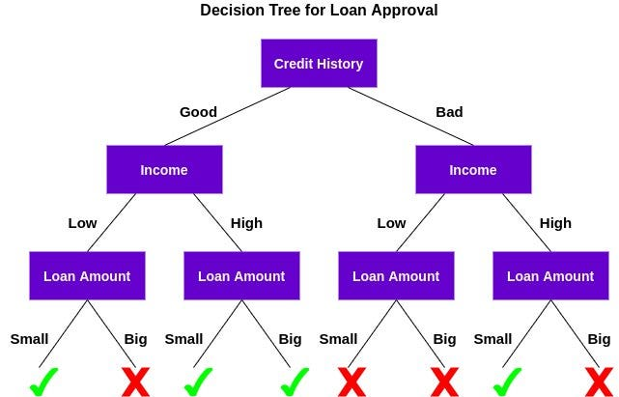

Illustration of a decision tree in action for a Loan Approval

In healthcare, machine learning is being used to analyze medical data and make predictions about patient outcomes, such as the likelihood of developing a certain disease. In finance, machine learning is being used to analyze financial data and make predictions about stock prices or credit risk. These applications of machine learning are improving outcomes for individuals by enabling earlier detection and more accurate predictions. In addition, businesses are using machine learning to improve decision-making and reduce costs, leading to better outcomes for both companies and individuals.

**Machine Learning in Healthcare**

*In the healthcare industry, machine learning is used to improve patient outcomes and reduce costs. One area where machine learning has a significant impact is medical imaging. Machine learning algorithms can analyze medical images to identify abnormalities, such as tumors, with greater accuracy than human experts. This can lead to earlier detection and more effective treatment. For example, a study published in the Journal of the National Cancer Institute found that a machine learning algorithm was able to accurately identify breast cancer in mammograms with an accuracy of 94.5%, compared to 88.1% for radiologists.*

*Machine learning algorithms, which are based on mathematical models, enable computers to analyze data and identify patterns. One of the most widely used types of machine learning algorithms is the neural network. A neural network is a set of interconnected nodes or neurons that work together to recognize patterns. Each neuron receives input data, processes it using a mathematical calculation, and produces an output. This output is then sent to another neuron for further processing, and this process continues until the final output is generated. In essence, a neural network is modeled after the structure of the human brain and is designed to learn and adapt to new data over time. Neural networks have a wide range of applications, from image and speech recognition to natural language processing and predictive analytics. They are instrumental in areas where traditional programming methods are difficult to use, such as for tasks that involve large amounts of unstructured data.*

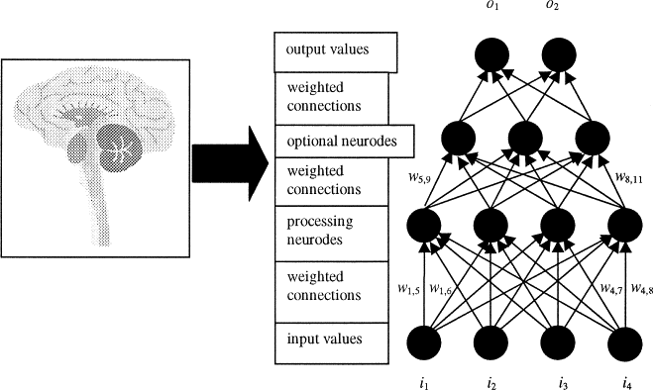

Artificial Neural Network

**Machine Learning in Finance**

*Machine learning has become a powerful tool for analyzing large amounts of data and identifying patterns in various industries, including finance. In finance, machine learning algorithms are used to analyze stock prices, predict future trends, and identify fraudulent activity. For example, machine learning algorithms can analyze historical stock data to predict future trends, helping traders make better investment decisions. Machine learning can also be used to detect fraudulent activity in credit card transactions by analyzing patterns of spending and identifying unusual transactions.*

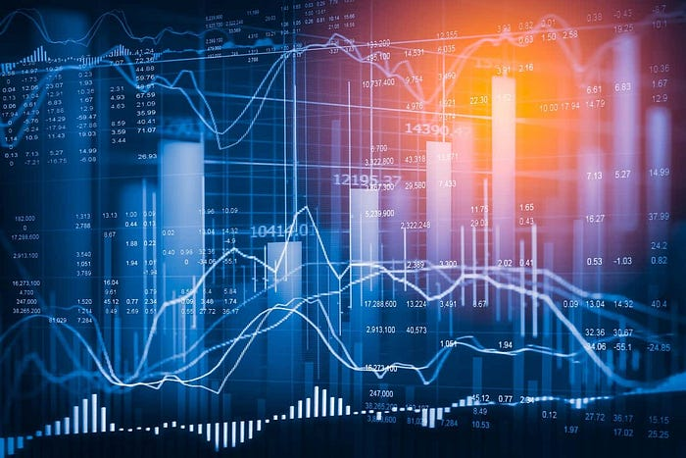

*Another area where machine learning is having a significant impact on the finance industry is customer service. Chatbots powered by machine learning algorithms are being used to provide customers with personalized recommendations and answers to their questions. These chatbots use natural language processing to understand customer inquiries and provide accurate and timely responses.*

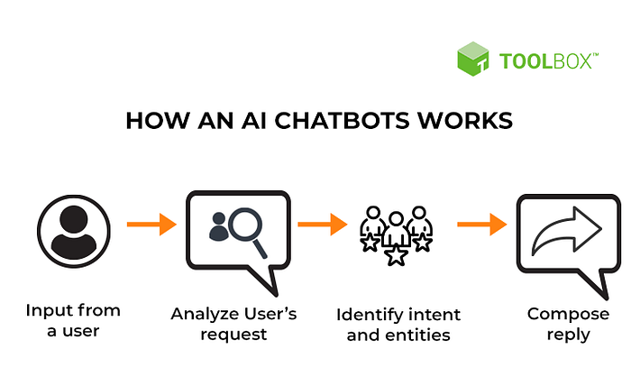

Chatbot Working flow

*One commonly used machine learning algorithm in finance is the decision tree. Decision trees are flowchart-like structures that classify data based on a series of binary decisions. Each decision is based on a single feature of the data, and the tree branches off in different directions depending on the outcome of each decision. In the finance industry, machine learning algorithms can be used to optimize investment portfolios. By analyzing large amounts of financial data, these algorithms can identify patterns and predict future market trends. Portfolio managers can use this information to make more informed investment decisions, ultimately leading to higher returns for investors. Additionally, machine learning algorithms can help financial institutions identify opportunities to reduce costs and improve efficiency by analyzing transaction data and identifying areas for optimization.*

Machine learning is rapidly transforming the healthcare industry, with applications ranging from drug discovery and personalized medicine to medical imaging and patient monitoring. For instance, machine learning algorithms can analyze medical images such as X-rays and MRIs to detect abnormalities and help doctors make more accurate diagnoses. In addition, machine learning can help predict disease outcomes and identify patients at risk of developing certain conditions, enabling earlier intervention and potentially better health outcomes.

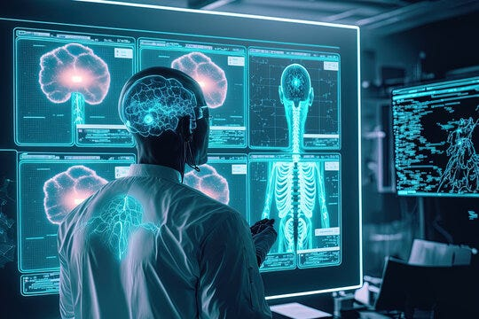

In finance, machine learning is being used to analyze large volumes of data and identify patterns that can be used to make better investment decisions. For example, machine learning algorithms can analyze stock prices and predict future trends, or analyze credit card transactions to detect fraudulent activity. Machine learning is also being used to improve customer service in the finance industry, with chatbots powered by machine learning algorithms that can answer customer questions and provide personalized recommendations, improving the overall customer experience.

As machine learning continues to evolve, we can expect to see even more applications in a wide range of industries. For instance, in manufacturing, machine learning can be used to optimize production processes, reduce defects, and improve product quality. In transportation, machine learning can be used to improve traffic flow, reduce congestion, and enhance safety. In agriculture, machine learning can help optimize crop yields and reduce waste, while in retail, it can be used to improve customer engagement and optimize inventory management.

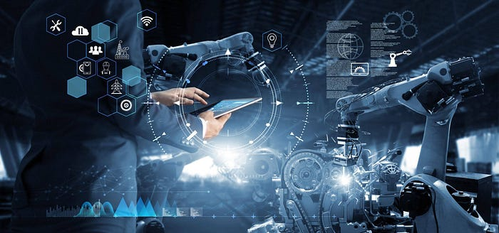

It is important for individuals and businesses to stay up-to-date with the latest developments in machine learning to take advantage of its potential benefits. By incorporating machine learning into their operations, businesses can make better decisions, improve outcomes, and reduce costs, ultimately leading to increased productivity and profitability. Additionally, individuals can benefit from the improved services and products made possible by machine learning, leading to a better overall quality of life.